**Quiz2**

**Sanghyuk Lee(129405171)**

**QUESTION 1**

1. Answer the following questions. You need to practically develop Q1~Q4 in Matrix. For Q5 and Q6, you can use your word to explain it (you can also demonstrate it in Matrix and explain it).

Make sure to submit a MS-Word file which contains all answers and screenshots .

**Question 1)** Create a script (name it as Q1_yourname.sh) which does the followings: (2 marks)  
A.    Create an array (name it WORDS) with the following data  
      spy spider spiderman spin spiderweb spiral sport sportswear sportscast  
B.    Display the size of the array  
C.    Display the length of each word in the array  
D.    Display all elements except the first two  
E.    Replace spid with SpID .

**Code:**

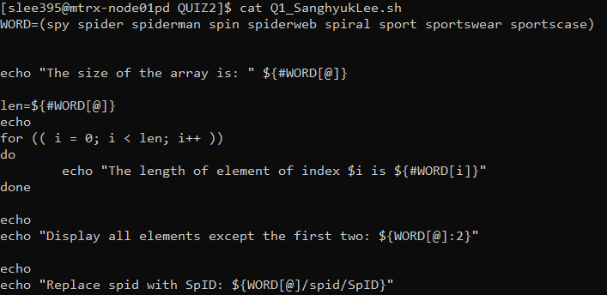

**Output:**

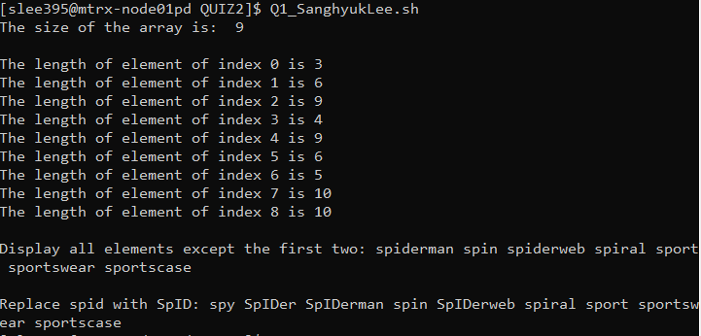

1. Created required array using compound assignments
2. By doing ${#WORD[@]}, I could display the size of the array
3. By using for loop, I accessed each element one by one and display the length of each element using ${#WORD[index]}
4. ${WORD[@]:2} display all the elements except the first two
5. ${WORD[@]/spid/SpID} substitutes the words

**Question 2)** Create a script (name it as Q2_yourname.sh) which does the followings: (1.5 marks)  
A.    Create an associative array (name it myCourses) which stores your current courses in this semester (more than three courses) in the following format:

*pairs of "Course Code" and "Course name", like "storing ULI101" and "Intro to Unix" into the Array.*

B.    Display all the array data (both course code and course name)

**Code:**

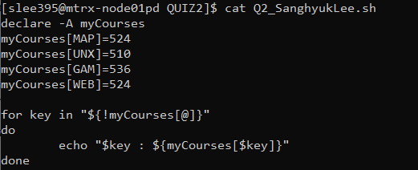

**Output:**

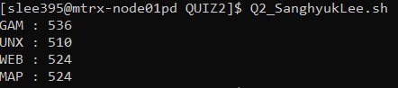

**Question 3)** Design a function which takes two number from input and calculate the total and display it. Show how the function works. (1.5 marks)

**Code:**

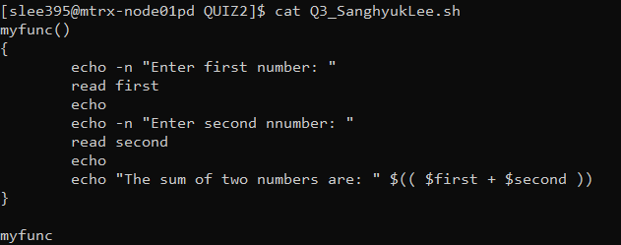

**Output:**

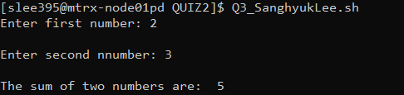

**Demonstration)**

First, the script inside call the function myfunc using function call feature.

The function myfunc of question3 accepts two value from user input and it calculates the sum value and echo

**Question 4)**Developa script which when executed perform the following actions: (2.5 marks)

a) Clear the page and display "Welcome to amazing script!" on the first line

b) if user press Ctrl+C, it displays "You Press Ctrl+C" on the first line

c) if user press arrow keys (Up, Down, Right, Left) it display proper message like "You press Up" on the first line

d) if user press "q", it exit from the script  ( the screen/cursor should be back to normal).

**Code:**

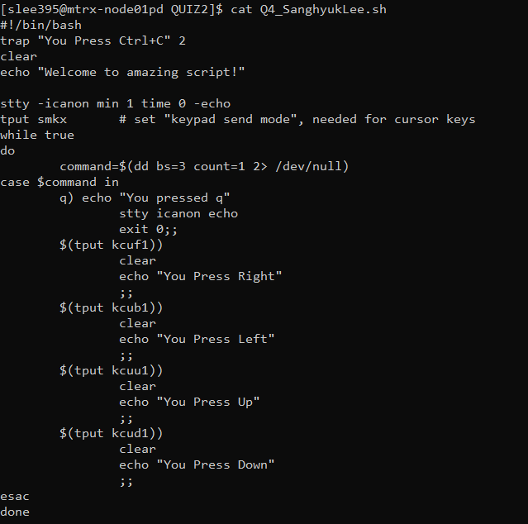

**Output:**

When you run the code what it firstly shows is the following:



When you press one of the cursor then it shows following:

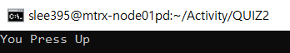

When you press ‘q’ then it shows ‘You pressed q’ and exit

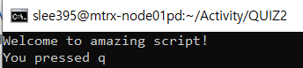

**Question 5)** Consider the following script (script1.sh): (1.5 marks)

while getopts ab:c opt  
do  
   case $opt in  
       a) aflag=1 ;;  
       b) bflag=$OPTARG ;;  
       c) cflag=1 ;;  
   esac  
done  
if [ "$aflag" = 1 ]  
   then echo "You entered option -a."  
fi  
if [ "$bflag" != "" ]  
   then echo "You entered option -b with keyword \"$bflag\"."  
fi  
if [ "$cflag" = 1 ]  
   then echo "You entered option -c."  
fi

Explain how it works when you call the script as follow : **script1.sh  -bx**

**Demonstration)**

When user provides option ‘b’ with the value ‘x’, then the value of OPTART will be ‘x’ and as it is not empty since you have initialized the variable bflag with the value of OPTARG which is x in this case, it will show the following output:



**Question 6)** Based on the experience that you have with name-pipe, explain how it works using a simple example.  (1 mark)

Named-pipe works with two processes with one content. Once you input then the process1 will be waiting until the process2 which is reading will be implemented. The example will be the following code:

Write file:

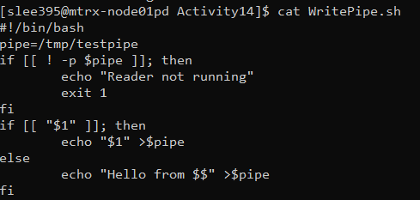

Read file:

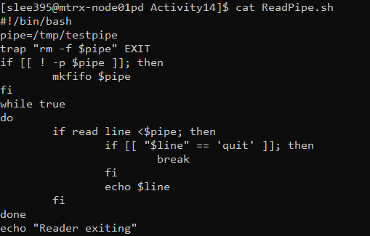

**Demonstration)**

Inside the Write file, once you checked that the variable you set is verified as pipe, then you implement the second if statement which is redirecting the output to the pipe.

Inside the Read file, once you checked that the variable you set is verified as pipe, then you accept the input and echo it.